DEWBERRY PARENT COUNCIL MEETING MINUTES
APRIL 19, 2023

Members present: Kristen Rewuski, Tyson Lancaster, Shannon Wyard-Scott, Krista Bensmiller, Rhonda Scanson, Stacey Nelson, Krystal Becker, Darlene Goldsmith, Lindsey Carlin, Darlene Bensmiller, Tamara Stachniak, Laureena Kipps; students present: Blaze Bensmiller, Sienna Bensmiller, Kamleigh Wyard-Scott

Lisa Bensmiller called the meeting to order at 6:45pm.

Darlene Bensmiller presented the treasurers report. The current balance is $5701.26.

There was discussion about the last fundraiser and next year it will be based on paper copies.

Laureena Kipps made a motion to adopt the minutes from the last meeting as read. Tamara Stachniak seconded the motion. All members voted in favour.

Blaze Bensmiller, Sienna Bensmiller and Kamleigh Wyard-Scott did a presentation about what they have been working on in their Environmental Stewardship class. The students made a proposal to have a greenhouse for the school to help benefit the school and the community. They would like to plant flowers and vegetables. They will use the flowers to make baskets for the community and have the vegetables to use for the lunch program.

Krista Bensmiller inquired about the fall class schedule including math and science being ran all year long instead of just one semester. Tamara explained that she spoke to the math teacher and Mr. Mclean prefers the 80 minute class option as there is more time for instruction and in class work than with the 40 minute class.

Stacy Nelson asked about the June lunch order. The last hot lunch date will be June 19.
Krista Bensmiller will pick up the hot lunch for June 5 and Laureena Kipps will pick up the lunch for June 19.

Fundraising Update- the school is required to send in a request host a fundraiser to BTPS to get permission to create a school based fundraiser. Tamara reviewed the details of what the school council consists of.

Principals Report- Tamara Stachniak

Principles Report April 19, 2023 School Council
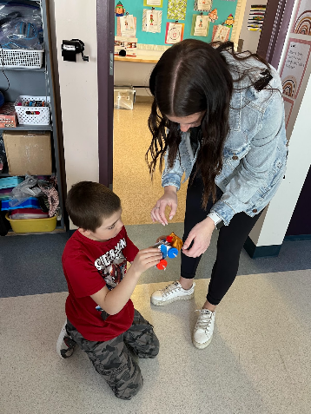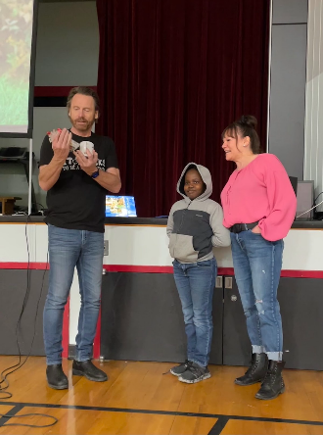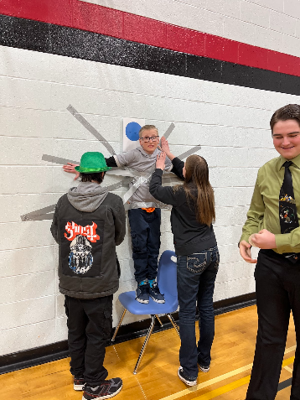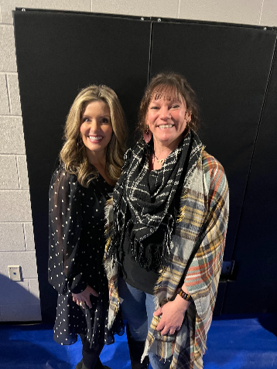

- Alberta Education Assurance Measures Spring 2022
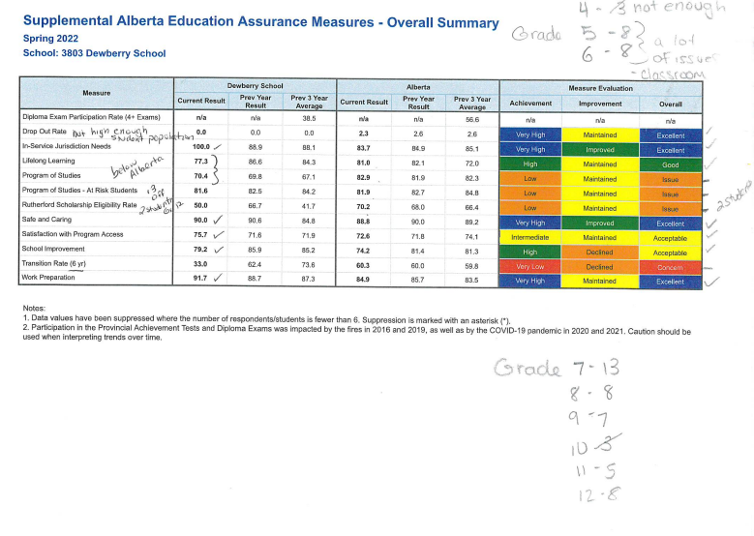
Link Alberta Education Assurance Measures 2022.pdf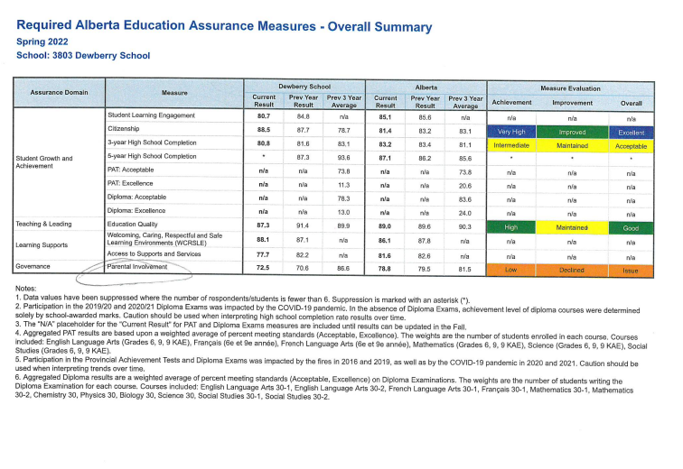

- Spring Fling Friday, May 12 1:00
(kept afternoon in case people needed to go somewhere for the evening or weekend)
Performances from Grades K-6, JR High will provide parts of the program
Celebration of Learning-each class will have a few stations for your student to show you something that they have been learning

- Budget

Future Purchases
Panel Boards
New PC’s and Monitors
Greenhouse

Current Balance
$32,000.00?
This year’s budget
We will have a few changes we must endure to the dollars we have been given.

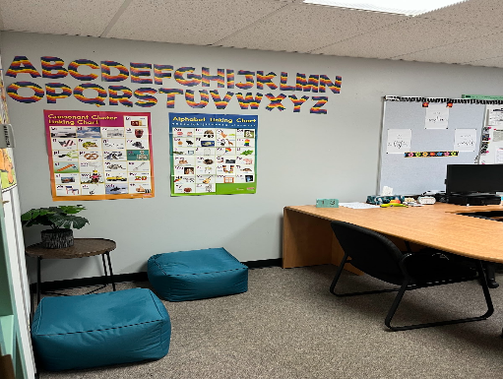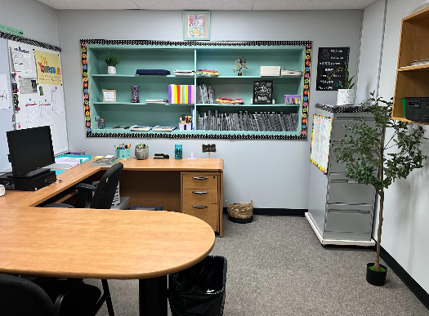
- Lisa Bensmiller-Tier 2 Program
Reading Events: Igniting the Passion for Reading
SeeSaw Reading Challenge 20 000 minutes Staff and Students
May-Outdoor activity
June -Chuckwagon community

- TimeTable
Changes for the fall
Synchronous-virtual (teacher and student same place, same time)
Asynchronous-virtual (student has own schedule, lectures, readings, anytime of the day)

- Fundraising
602.12AP Fundraising https://www.btps.ca/download/366013
506.1AP School Council https://www.btps.ca/download/365881

- Derwent Pizza
Lavina - manages kitchen 741-2407
8 inch $17. 25
1 large (8 slices) $27.50 + GST
Open at 11:00 but would open earlier to make our pizzas and we could pick them up by 11:15
Wednesdays work best for her
2 large, 2 topping , free 2L pop $50.50
Could do by the slice

- New Curriculum
Grade 4, 5, 6 LA, Math
Grade 1-3 Science, Fine Arts

- Student Environmental Stewardship Class
Greenhouse letter-Looking at having a Greenhouse, sharing types of plants, cost and purpose.
Shop class in Marwayne, April 24-May 12, 3 weeks, just Grade 9 due to numbers allowed in the shop.
Bus $2, 394.00, Stan Fox paid sub wage for 3.5 days at $220.00 a day.
Leave at 10:10 return by 12:05-12:10

10.Questions?

Lisa Bensmiller- Reading Program – updated on the different ways that we can encourage reading in the school. Lisa has asked for a donation of $500 to supply prizes for the reading challenge. Kristen Rewuski made a motion to donate $750 to the reading challenge, Darlene Bensmiller seconded the motion and it was carried.

Tyson Lancaster said thankyou for the donations of the gift cards for the public speaking competition.

School clothing -Laureena will contact Northshore Promotions about a quote for school clothing.

Darlene Bensmiller asked about the bathrooms doors and if we can get doors on the entrance to the bathroom. Tamara said that letters can be written to the school division asking for some sort of privacy for when you are using the sink.

Shannon Wyard-Scott asked about the school dress code.

Stacey Nelson made a motion to ask the school division if we can have a mom’s pantry fumdraiser in September 2023. Darlene Bensmiller seconded the motion, and everyone voted in favor.

The parent council will not be doing the community calendar as the Dewberry Fire Hall has taken the task on.

The next meeting will be on Wednesday June 7, 2023 at 6:30pm

