Dewberry Parent Council Meeting
December 5,2022- CTF Lab @ Dewberry School
Members present: Lisa Bensmiller, Stacy Nelson, Laureena Kipps, Lindsey Carlin, Tamara Stachniak, Kristen Rewuiski, August Bensmiller(student council rep), Darlene Goldsmith, Krystal Becker, Darlene Bensmiller

The meeting was called to order at 6:41pm. Darlene Goldsmith is joining the council as a community member.
Treasurers report was read and the current bank balance is $4388.36. Laureena submitted a receipt for the donuts for the awards day.
August Bensmiller gave an update on the school dance. The dance will run from 8pm-12am. The canteen will have pop and chips and snacks. Krista Bensmiller has emailed ladies from the community to donate baking for the event. Any extra baking that doesn’t get sold will be sold at the school Christmas concert. Each item will be $1. Admission to the dance is $5. Door prizes for the dance are a blue tooth speaker donated by Shannon Wyard-Scott. There will be other gift cards given away as well. Tamara will look into how the paperwork needs to be filled out for the dance as its not a direct school event. Clean up will take place the night of the dance.

Dance volunteers are Stacy Nelson, Laureena Kipps, Kristen Rewuski, Lisa Bensmiller and Dacia Stone.
Tamara presented her principals report.
Principal Report: Tamara Stachniak
Visit to Myrnam
Greenhouse
-Community use of an attached building/shop
-Started with one green house and a grant for $5000.00 from A+ Energy
-They now have two greenhouses and had many teachers working on the project, Science 7 was a large contributor.
-One greenhouse stores the rainwater in large barrels
-The rain water has to be filtered, it seeps into a large tank
-Now they have hydroponics in another room for the eco group
-They have four different projects happening in the large attached shop
-They have about 30 junior high students working on these projects-greenhouse, mechanical, eco & tiny house along with other side projects
Pictures below:
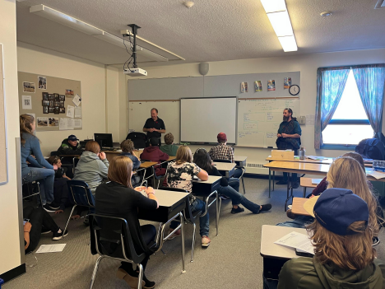
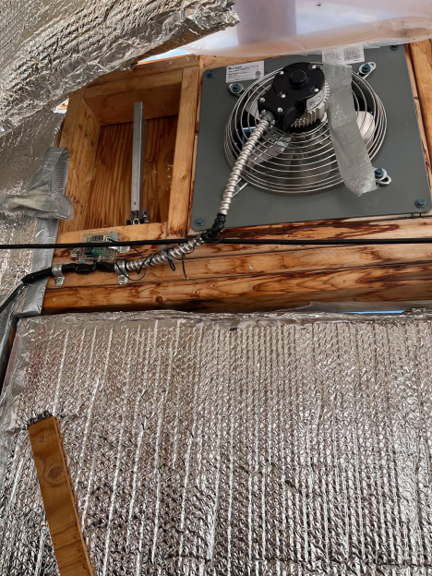
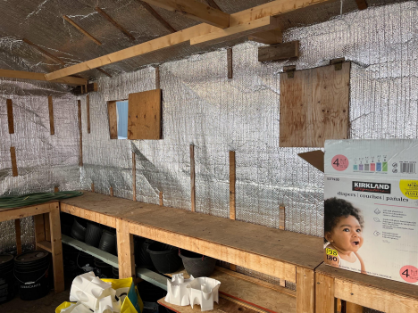
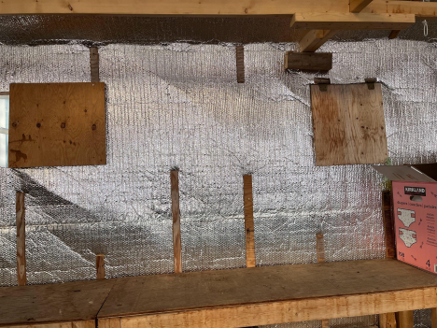
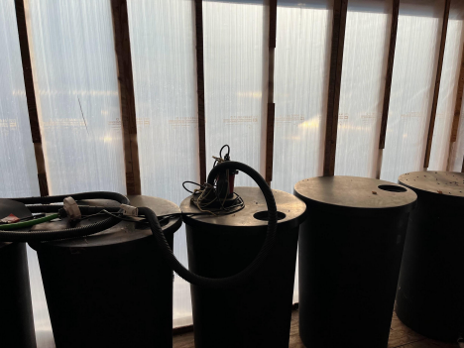
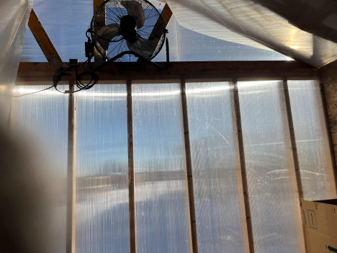
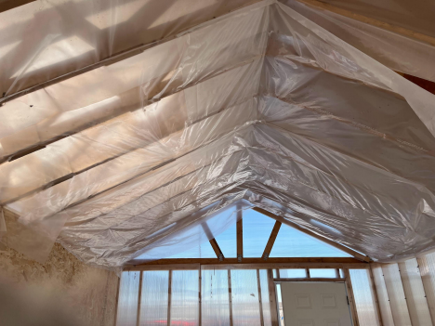
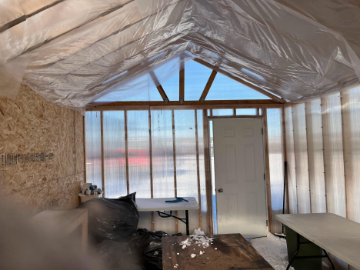
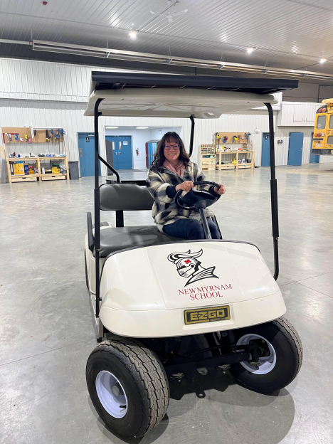
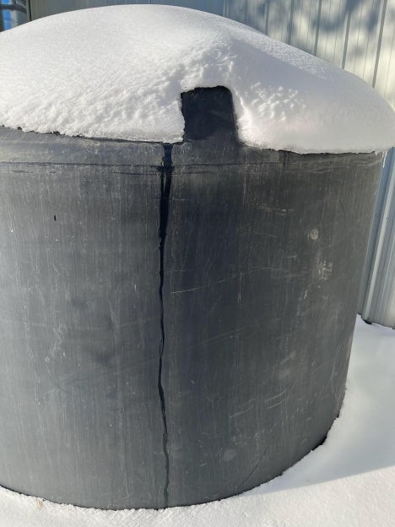
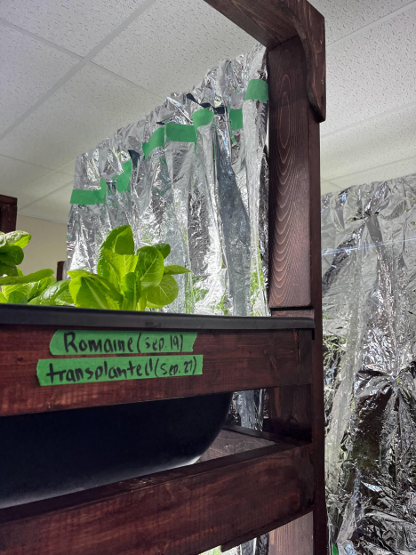
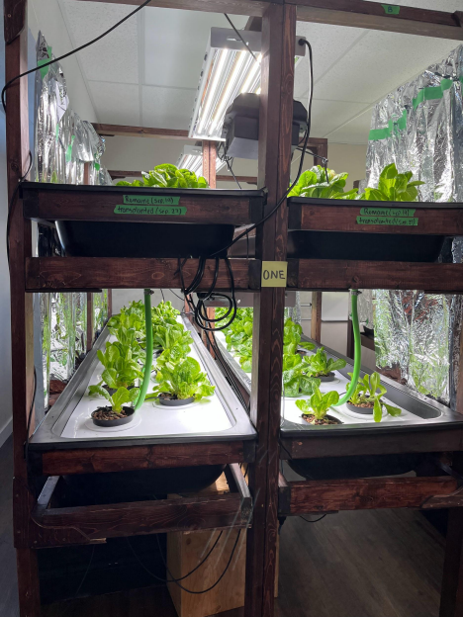
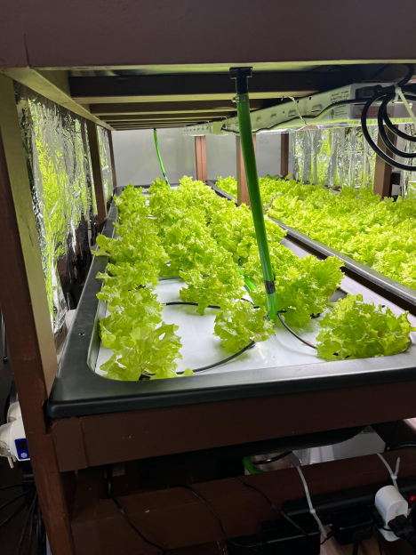
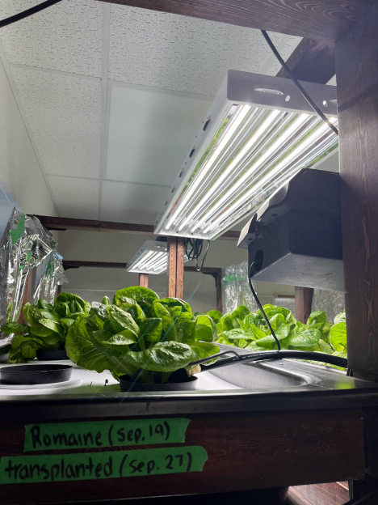

What does this look like for Dewberry School?
-We have 30 students in one class
-We have less support a lot of their support comes from additional EA’s
-We do not have access to an attached building but could we find another place? -I have been told we would not get a shop due to the cost for fans for the building of the greenhouse. It is winter when the course starts, a little cold to work with equipment outside. -I am looking to reach out to the AG Society and the County of Vermilion River. -I am also looking at reaching out to Marwayne to use their shop and give our students time with carpentry, $220.00 a day for sub and bussing.
-I have also contacted Lakeland College to take my students on a tour there.
New Hire starts next week
Jill Holgate has been hired full time to assist and support in the Grade 1/2 classroom.
Awards Ceremony
Please share any additional thoughts you would like us to consider. I like the idea of moving it earlier in the year ��
I think the children would want there moms, dads, grandpas and grandmas there, it’s a honour for anyone that gets an award to show how much hard work they have put in and my children would want family there
I know this is hard either way. My kids have said that if it’s in the evening some students cannot make it and if it’s in the day, I cannot make it to see my kids hopefully receive some awards. In order for myself as a parent to attend, I would need significant time to get that off work. I do like September as opposed to October.
Having it at the same time as the fall supper always worked real well for everyone involved I think it’s nice to have the kids all be present to recognize each others’ achievements.
Just a really long time for young ones to sit.
More parents will be able to attend; as well as Award Donors. I feel Award's Night rates right up there with the importance of our Graduation ceremony. We are celebrating the success of "all" of our school population. The staff is also quietly acknowledged-when the students achievements are showcased.
I think more parents could attend this way and so could the trophy donors. It would be nice for more donors to be able to be present rather than staff handing out all of the awards. This night is almost as important as Graduation. This is a "school" celebration of our student's achievements. Would be best if parents new ahead of time so family could be invited
Would we be able to get an email letting us know if one of our kids is going to receive an award. They have done that in the past.
This is a farming community and September is usually the busiest month of the year. I hope you take this into consideration.
The Awards ceremony will be in the evening. The date will stay in September. We have tried to balance out the events in the end of October and the beginning of November. We had Halloween, Awards, and Remembrance Day. Our little staff can only do so much.
School Dance:
I am still waiting for a response from our Superintendent about a school supervisor.
Calendar Feedback:
Central office sent out a survey
Please fill out the survey
Calendar Feedback: Letter to Parents will download when you hit the link!
Small School Meeting
What are the individual challenges faced by each small school?
What are some of the supports needed?
How are the different areas such as scheduling, budget, PD, staffing, DL and others impacted in small schools?
AERR:
Dewberry School Assurance Planning 2021-2022
Dewberry AERR
Four Year Plan Future Dates
School Review:

A survey was sent out about the school awards ceremony and the awards ceremony will now be moved to an evening in September.

David Bensmiller gave his trustee’s report. There is an upcoming meeting on December 20,2022. There will be grants given out for mental health. Division 2 will get 2 emotional social coaches. Report any feedback we may have to the board about the changes.

December 23- 1pm school concert/2:30pm Santa Visits. The council will make 100 treat bags for the k-6 students to receive. Laureena will buy the supplies and make the bags.

Swimming lessons will be January 16-19,2023 for Grades 1-3 and March 6-9 for Grades 4-6.
Next meeting will be February , 2023 @ 6:30pm.

